Brief Study of User Mobility Mode

1. The mobility pattern  
   Fig. 1&2 shows the movement of an arbitrary user. Since the user’s position is solely determined by the location of the tower which the user directly communicated to, the movement of users thus consist of a sequence of pulses as shown in figure 1&2

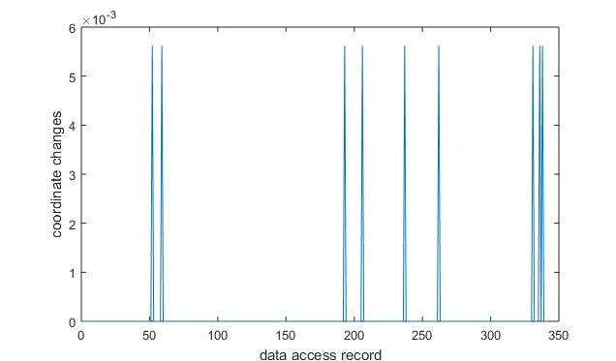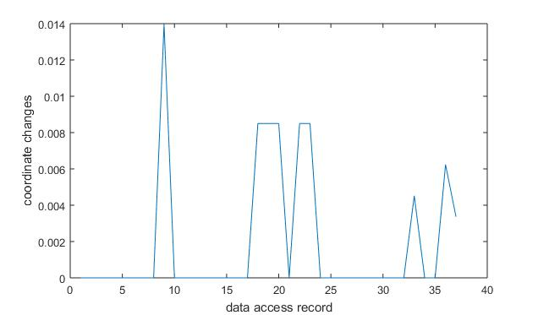

1. Computing user’s speed from their data access  
   It’s quite hard to infer user’s speed from these pulses. For example, the records may tell us that a user initiated a data connection at Tower A and after 45 minutes initiated another data connection at Tower B, this could lead to several possibilities:
   1. Lacking of continuous observation:
      1. The user drive from A to B in 15 minutes and stay at B for 30 minutes before the user initiate the second data connection
      2. The user walk from A to B in 45 minutes and initiate the second data connection right after he arrives
   2. Lacking of fine grained location information (there are only 122 towers in the example city):
      1. The distance between user’s two consecutive data connection location is actually 1 mile.
      2. The user was just located at the intersection area, and for some reason his phone automatically handed over from A to B while he actually didn’t move at all.

I’ve been tried to overcome the first problem by only using the consecutive movement, such as the user move through several towers, to infer the user’s speed. For situations like the example above, I just counted it as static and I get the following results in figure 3. Note that I limit the speed range in 0~80km/h.

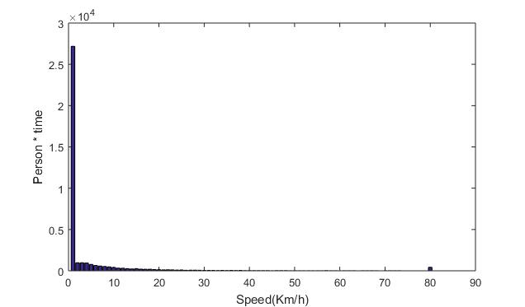

The reason that most users are count as static is that most user movement are actually very short thus treated as static by the algorithm.